Name: _________________________ Narrogin Senior High School


Unit 3 Modern History

SOURCE ANALYSIS

PRACTICE PAPER

Australia 1918 - 1955

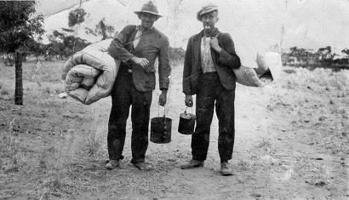

Marks out of 25:

Weighting - 5 %

SECTION ONE: SOURCE ANALYSIS SET 1, Unit 3

This section has ONE question made up of FIVE (5) parts. Attempt ALL parts. Write your answers in the spaces provided.

- The marks allocation for this section is 25 marks.

- Allow approximately 45 minutes for this section.

Indicate below the document set from the Document Booklet you will use to respond to this
question.

Set 1: □ Australia 1918–1955

Set 2: □ Russia and the Soviet Union 1914–1945

Set 3: □ China 1935–1989

Question 1

- Explain the historical context of Source 1. Include the relevant events, people and ideas depicted or represented in the source. (4 marks)

The historical context of Source 1 is:
the heavy borrowing from Britain during the Bruce/Page Government of the 1920’s
The reliance on British funds for the economy
The expectations of paying those loans back during the Gt. Depression that started in October 1929 and was to continue until 1939
Sir Otto Neimeyers expectations for Australia to honour its debts and the restrictions this put on the Labor Scullin Government to combat the effects of the economic crisis – like a strangle hold on the life and growth of the nation, as evidenced in the image drawn – held back by the Bank of England.

SOURCE ANALYSIS SET 1 cont…

(b) Compare and contrast the purpose of Sources 1 and 2. (5 marks)

The purpose of Source 1 is:
To indicate how much of the effects of the Depression were to be blamed on the Bank of England’s attitudes and approach to regaining the money lent to Australia during the decade of the 1920’s. The reason behind this purpose is to absolve Australia somewhat from the causes of the social, political and economic effects of the Depression, meaning it was largely the fault of Britain as a mentor that led Australia unexpectantly into the crisis. This was emphasised even more when Otto Niemeyer visited Australia as a financial advisor, yet still blamed Australia for living beyond its means, even though Britain was largely at fault for lending them that money that moved Australia into the crisis like much of the industrialised world at the time.

The purpose of Source 2 is:
To highlight that the Scullin Government was very much a victim of circumstance to be elected on the eve on the economic crisis, unable to initiate any reforms and that the Stock Market Crash of 1929, albeit the catalyst for the Great Depression, the source presses the point that it was the obligation to pay loans off to Britain that exacerbated the economic situation.

Similarities: Both indicate Britain as the source of economic troubles for Australia
Both indicate Australia as victims of the economic crisis

Differences:

(c) Describe the message of Source 3. (3 marks)

The message of Source 3 is that Jack Lang came to the realisation that he had to start and do something proactive about the effects of the Depression to help to solve it, particularly in defence of the working class. He accuses the Government, under Scullin and Theodore, of avoiding the main issues of the economic crisis and being reluctant to deal with the problems at hand, fearful of upsetting various parties such as the unions. Lang announces that he is not fearful of a fight, to do what is right, and that he is prepared to make himself politically and personally vulnerable because the fight for the working class is worth putting up with for the benefit of the people; besides, he sees no one else brave enough to stand up for what seems right ‘ I realised that if I did not put up a fight we would all go down..
SOURCE ANALYSIS SET 1 cont…

(d) Identify and discuss why Sources 3 and 4 are contestable. (6 marks)

SOURCE ANALYSIS SET 1 cont…

(e) Using your knowledge of the whole period of study, evaluate the importance of the
themes, ideas and/or events represented in the four sources. (7 marks)

END OF SECTION FOUR

Question number:

Question number:

SOURCE ONE
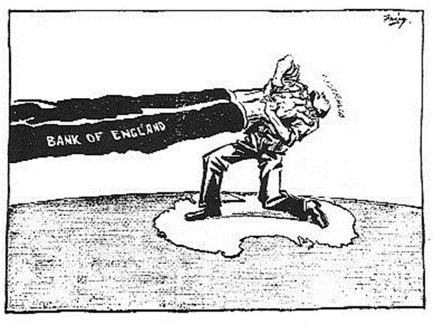

Publication unknown, circa 1930, Australian press.

SOURCE TWO

When the 12th Commonwealth parliament was opened a month later on 20 November 1929, the new government introduced a program it could not implement once the reality of economic depression unfolded. Scullin immediately ended the licensing system for waterside workers imposed by the Bruce–Page government, but this was not the time for implementing industrial relations reform. The Rothbury miners’ strike in New South Wales was a severe test of the new Labor government, as was the unemployment escalating throughout Australia.
Plummeting export income and consequent worsening of the trade imbalance had been dealt with by the Bruce–Page government by exporting gold reserves. Even before Scullin was sworn in Robert Gibson, Commonwealth Bank Chairman, had sought a meeting to advise the incoming Prime Minister of the effect of this trend given the high level of Australia’s overseas debt. It was not the collapse of the New York Stock Market in October 1929, but the burden of loan repayments due to London bankers that revealed the stark situation for Australia when parliament resumed in March 1930.

From the National Archives of Australia collection, information sourced from the Scullin ministry, folders of typed copies of Cabinet minutes, 1929–31, NAA: CP450, 1, Bundle 1/4

Source 3
During the weekend in Canberra after listening to two days of fruitless argument, I decided that the time had arrived for a showdown. Who were the real enemies of the Australian people? I was not prepared to load the blame on to the workers. They were under attack all the time. They were being blamed for the depression. Their wages were said to be too high.
Theodore and Scullin were hedging. They were not prepared to face up to Labor policy. On the one hand they were afraid of the bankers, and on the other hand did not want to antagonise the trade union movement. They were trying their hand at tight-rope walking. But their umbrellas were already exposed to the rim. The usurers were certain to win.
I always believed in the old principle that the best form of defence is attack. For six months the bankers had been on the attack. Theodore was no more anxious for a showdown than Lyons. I realised that if someone did not put up a fight we would all go down, and with us the Australian economy.
The Birth of the Lang Plan, Jack Lang.

Source 4

